**Understanding the Functional Systems of a Bicycle**

A bicycle is a two-wheeled vehicle that converts human pedaling force into motion, providing an efficient and affordable means of transportation. The bicycle is composed of a frame with several systems mounted upon it to allow the rider to control the bike’s movement and direction. This includes a drivetrain system for propelling the bike forward, a braking system for stopping motion, and a steering system to control the direction of movement.

# Frame

The frame of a bicycle provides a structure for the other systems to attach and supports the weight of a mounted rider. Frames are made from lightweight, durable materials like steel, aluminum, or titanium. Modern bike frames are shaped like a diamond consisting of a front and rear triangle as shown in Figure 1. This geometry creates a rigid structure from little material, keeping the bike light. A seat is mounted on the frame for rider comfort. The frame provides a stable base that supports both the rider and the functional systems.

Figure : Bicycle frame with the triangular geometry highlighted.

# Drivetrain System

The drivetrain system propels the bicycle forward. It is comprised of the crankset (pedals, crank arms, and chainring), the chain, the cassette, and the derailleur. Figure 2 shows a modern bicycle drivetrain.

Figure 2: Modern bicycle drivetrain. Pedals not pictured.

## Crankset

The crankset is the mechanism that connects the pedals to the rest of the drivetrain system. Each of the two pedals is mounted onto its own crank arm. These crank arms attach to a toothed chainring. The crankset is secured to the frame through the bottom bracket axle. The crankset’s purpose is to transfer the rider’s pedaling force to the chain.

## Chain

The chain is a loop of metal links that sits upon two sprockets, one being the chainring. Force from the crankset moves the chain to transfer energy to the cassette sprocket on the rear wheel. Regular cleaning and lubrication of the chain ensures smooth operation.

Figure 3: Main functional components of the crankset (Bottom bracket not shown)

## Cassette

A bicycle cassette is a set of sprockets that vary in size that are affixed to the rear wheel. The cassette allows the rider to change gears. Shifting to a larger gear makes pedaling easier but slower. Shifting to a smaller gear makes pedaling more difficult but increases speed.

## Derailleur

The derailleur shifts the chain between different sprockets while maintaining consistent tension. The chain is threaded through the derailleur, which accurately guides the chain onto an adjacent sprocket when shifting. Derailleurs are controlled through easily accessible levers mounted by the handlebars. Derailleurs are mounted near the rear wheel to shift between gears on the cassette. They can also be present by the crankset to switch between chainrings. The mechanism allows a biker to adjust to changing terrain by shifting gears on the fly.

# Braking System

The braking system allows the bicycle rider to slow down the vehicle or bring it to a stop. The system accomplishes this by applying brake pads to the wheels to create friction. Friction converts the kinetic energy of the wheels into heat, slowing the bicycle. The braking system is comprised of the following three mechanisms.

* *Control.* A mechanism for user interaction to control the brakes. This is usually in the form of brake levers mounted by the handlebars, similar to the derailleur control mechanism.
* *Signal transmission.* A mechanism to transmit force from the levers down to the brakes. This can be implemented with mechanical cables or hydraulics.
* *Brakes.* A mechanism to apply the force to the wheels to stop motion. The two most common types of brakes are rim brakes and disc brakes.

Rim Brakes vs. Disc Brakes

Rim brakes and disc brakes both accomplish the same goal of slowing or stopping bicycle motion but achieve this end in different ways that each have their own advantages. Figure 4 demonstrates the difference in location and appearance of the two brake types.

Figure 4:Disc brake vs Rim Brake

* *Rim brakes* apply brake pads directly to the rim of the wheel. Rim brakes are more cost-effective in upfront costs and maintenance. Their performance starts to slip in bad weather conditions.
* *Disc brakes* apply brake pads to a disc-shaped rotor mounted on the center of the wheel. They perform strong harsh weather conditions and on steep slopes. In turn they are more expensive and less universal.

Both rim and disc brakes are viable options for braking systems. A consumer may choose between them based on preference, budget, and the terrains/conditions they plan to face.

## Mechanical vs. Hydraulic Braking Systems

Mechanical and hydraulic braking systems both provide the same function of brake activation, but differ in force transfer, sensitivity, and maintenance procedures.

* *Mechanical braking systems* transmit force from the brake lever across steel cables to the brakes. They are cheaper and easier to maintain, but less powerful.
* *Hydraulic braking systems* use pistons to push hydraulic fluid through a sealed line to transmit force to the brakes. They have superior braking capability but are more expensive and difficult to maintain.

Hydraulic brake systems are recommended for consumers looking for superior reliability and performance, but mechanical brake systems offer a practical alternative for bikers on a budget.

# Steering System

The steering system of a bicycle allows the rider to maintain balance when riding and control the direction of motion. The components involved in this system are the handlebars, the fork, and the front wheel. In this system, the rider applies force to the handlebars to turn them. The handlebars attach to the bicycle fork through a part known as the stem, and the turning motion rotates the fork, in turn pivoting the front wheel as shown in Figure 5. The steering system results in intuitive and responsive directional control for the biker.

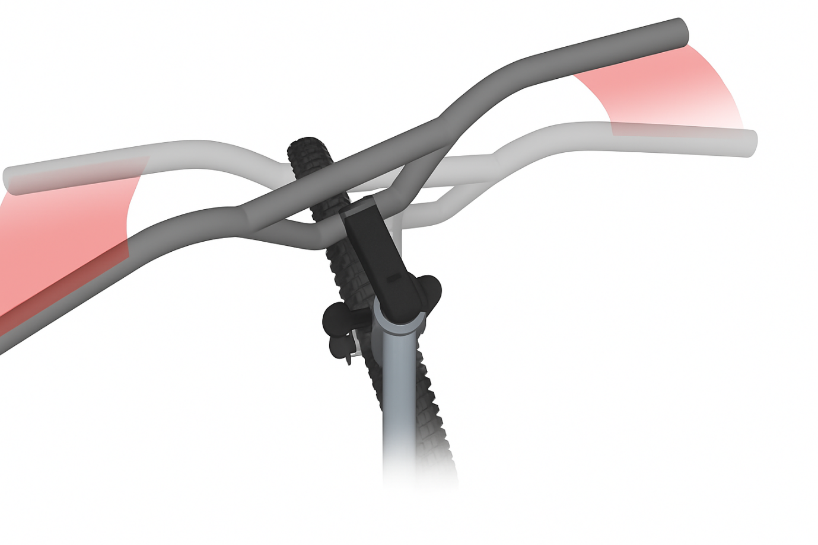

Figure 5: Effect of turning handlebars on front wheel angle.

# Conclusion

Bicycles provide an efficient, portable, and budget-friendly means of transportation. The drivetrain, braking, and steering systems all attach to the frame and work in tandem to create a reliable and easy-to-use machine. The drivetrain transfers human-generated force into forward motion, the brakes let the rider control speed, and the steering system allows for precise directional control. Bikes come in many different configurations, allowing the consumer to customize their bike to fit their environment and purposes. Thanks to its clever design and versatility in both fitness and commuting applications, the bike has long remained a mainstay in personal transportation.

# References

1 Image from <https://bike.bikegremlin.com/11319/bicycle-frame-design/> (Altered by ChatGPT)

2 Image from <https://en.wikipedia.org/wiki/Derailleur>

3 Image from <https://www.3dcadbrowser.com/3d-model/crankset-and-pedals>

4 Image from <https://www.cyclingnews.com/features/disc-brakes-vs-rim-brakes/> (Altered by ChatGPT)

5 Image from <https://crosscountrycycle.wordpress.com/2015/06/06/tiller-effect/> (Altered by ChatGPT)